29.60: a) 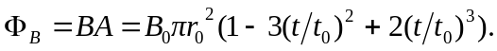
b)
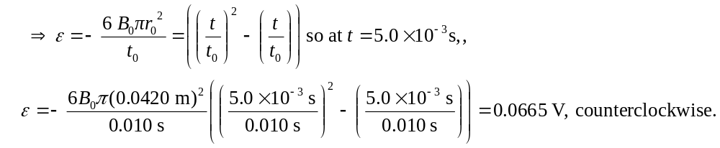
c) 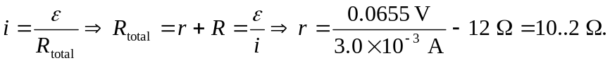

d) Evaluating the emf at 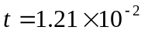s, using the equations of part (b): 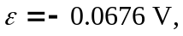 and the current flows clockwise, from b to a through the resistor.
e)